**A journey to Endo (the "End of the World")**

“We are going to Elgeyo-Marakwet. I hope you guys are ready. We will spend a night or two there. So carry enough clothing for the journey.” Magdaline, EldoHub’s Executive director said to me over the phone. “Yes we are. Okay. Okay. good day" I responded. I was more than delighted. I had never been to Elgeyo-Marakwet. Pictures of dry land and guns flashed my mind but for the love of adventure I was ready.

We, Christine, Esther, Magdaline and Viola, set out at 6am, cramped but comfortable in Mwaniki's small Wasili (an uber like taxi app) car, heading to Endo, a village in Elgeyo-Marakwet East County. Soft music from Abel Chungu made the atmosphere feel more spectacular as we watched the sun slowly rise. After driving for about two hours, we now entered Elgeyo-Marakwet County and we thought we only had one more hour to arrive so we rehearsed our boot camp schedule.

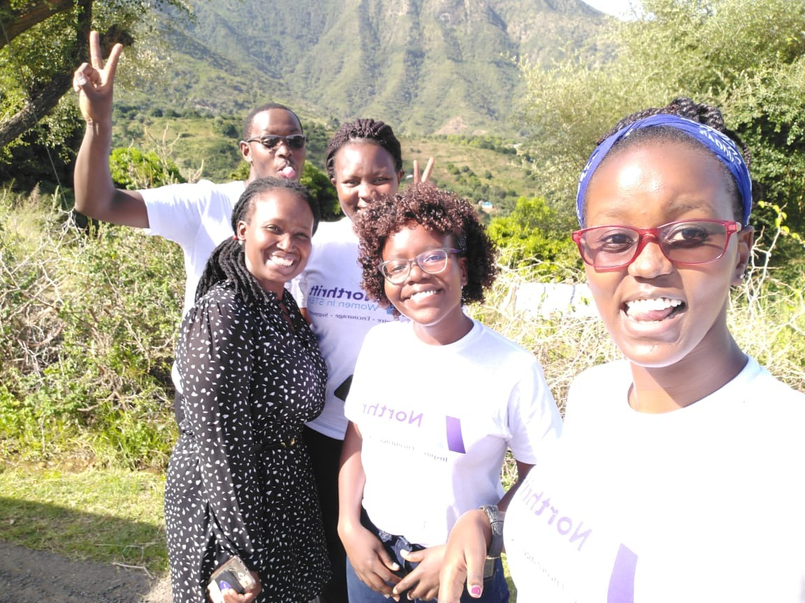

The tarmac road reached a dead end, and a rocky rough road stared blankly at us challenging Mwaniki's Wasili to a fight of brakes and gears. We went on, unshaken by the road. What seemed like a one-hour journey turned into a journey to infinity. Our focused turned to surviving the next bad depression or mini-hill. The environment changed. The trees were suddenly greener, the air was fresher and water flowed everywhere including through the road. We were at endo in Elgeyo-Marakwet East. Mango trees were everywhere, a homestead that lacked at least one mango tree seemed to be jinxed. Nature flourished. Ant hills were tall and made dominant significant presence at least every two meters.

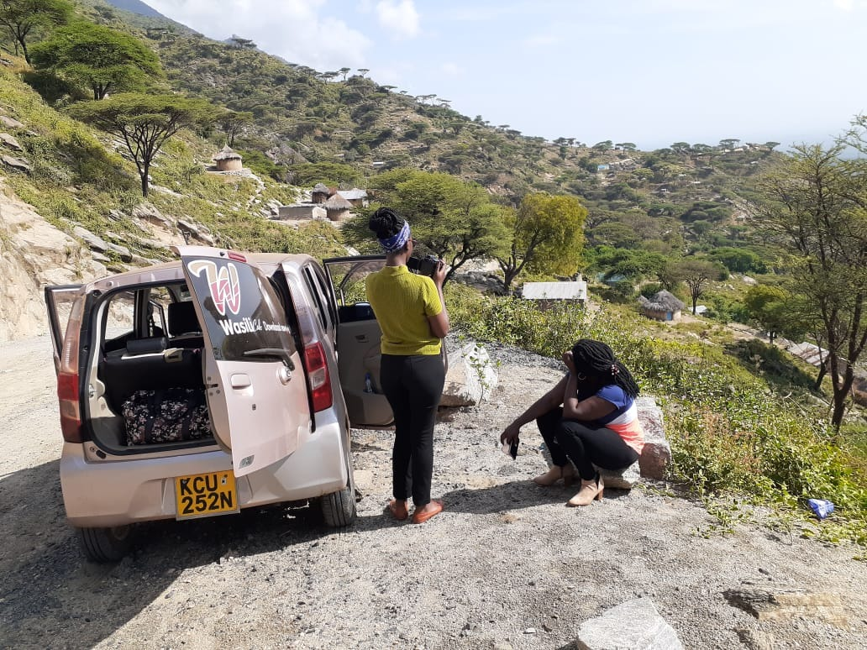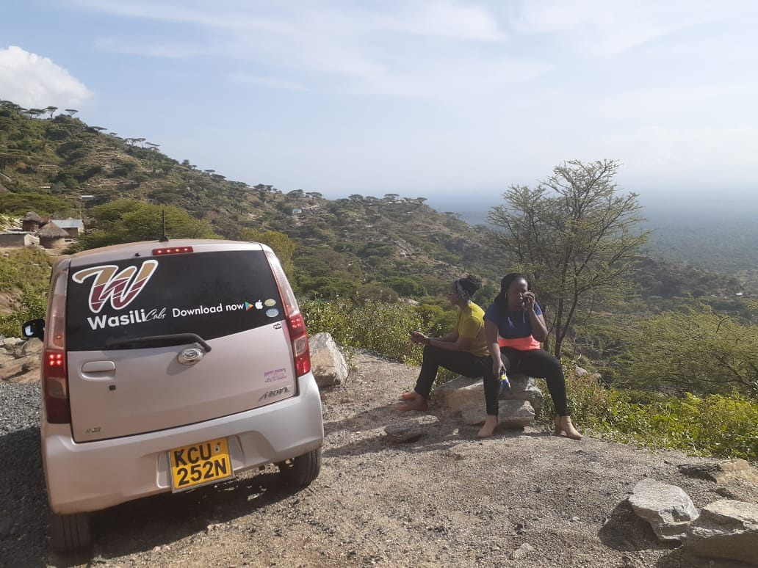

After what seemed like eternity, we finally pulled up at the blue gates of St. Abraham’s cathedral. And man did we heave a sigh of relief. Two boys with red checked shirts and grey shorts opened the gate with warm smiles and chuckles. Everyone calls him Father, because he is in charge of the parish and the church is the pillar of the war-ravaged ,resource-deficient and otherwise hopeless community. It was 11am.The anxious women had waited since 9am.We had a quick snack and started off with basics of a computer, Microsoft word , excel and PowerPoint. We ravaged through the applications fundamentals. Questions were asked and the women learnt quite a lot. We then did basics of coding ;creating websites using html .

We all went for a quick break and the rest of the afternoon was spent learning entrepreneurship. The women created groups and brainstormed on entrepreneural ideas. Happy, educated women went back to their homes later that day, trying to digest all the new information gained that day. It was a good first day.

Our last day in Endo started out great. Waking up from our cozy beds and watching the sun rise up was as glorious as ever. We were all very well rested and ready to venture out into another day full of more to learn and more to teach. We cleaned up and ad our breakfast and by 9: AM, we were set and ready to accomplish our day-plans. We were to first start with an hour of practical digital literacy to ensure that the knowledge they acquired is not only theory but practical as well. The only hick-up we had was lack of electricity but that did not stop us since two of our laptops were still charged.

The participants were a little late so our session started around 30 minutes late. The excitement and joy in their eyes during the entire session was proof that we had indeed done our part. They were all able to do one thing or another using Word and that was golden. We answered all their questions and interacted with them more while they got to know the practical bit of the computers. With the right resources, they will surely make a great improvement and impact in their community.

Afterwards Magdaline continued with the entrepreneurship training introducing the Business Model Canvas and how they can use it to come up with market fit business ideas for themselves and their community at large. She also taught on how to do idea hacks and gave the team a chance to group themselves and come up with solutions for challenges in their community that could be turned into business ideas. They came up with amazing ideas from the challenges they face and with our help even learned how to pitch their ideas. All the groups got a chance to pitch their idea to everyone including the Father of the parish, who was also present. All ideas were viable and with support and proper advice, they would probably uplift the status of the community. Once the pitching was done, the participants were given certificates and then we had a brief photo and networking session. We said our goodbyes to the participants at around 2:30 PM and then had our lunch before leaving Endo.

We took a different route back to Eldoret, passing through towns like Sambalat, Embobut and Chesoi. The ride back was filled with laughter, joy and a lot of adventure as we stopped so many times to view the beautiful hills, valleys, escarpments and skyline of the great Rift Valley. It was definitely a fulfilling journey and we have the pictures as proof. We had some troubles getting up on some of the hills that were too steep. (At one point we had to walk up the hill as the car could not hold our weights anymore) but thanks to God and our very able driver, Mr. Mwaniki, we made it back safe and sound.

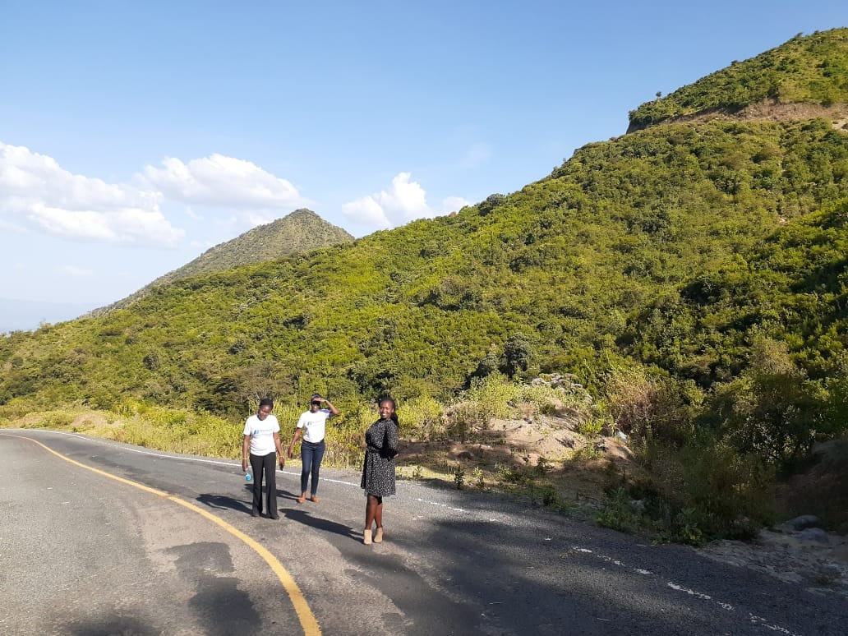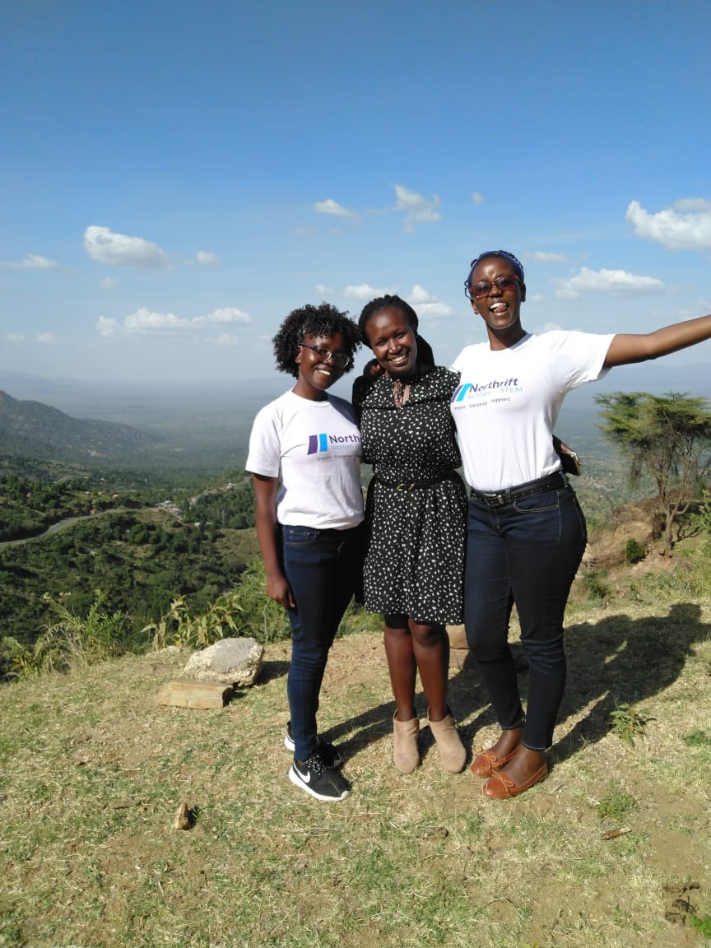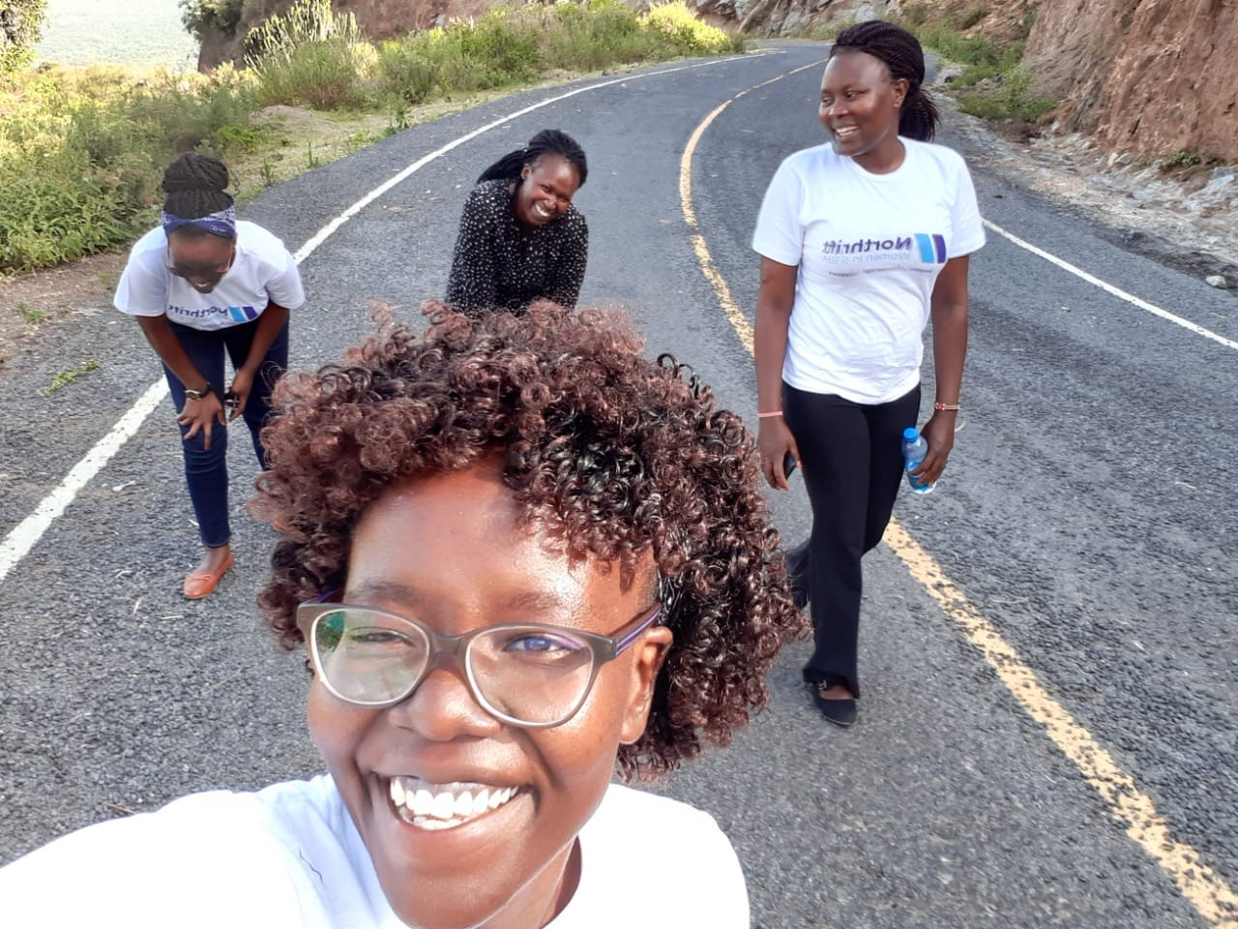

Thanks to EldoHub and the North Rift Women in Stem program, we were able to impact people’s lives positively as well as travel and have a fun-filled adventure all the way to Endo, Elgeyo-Marakwet County.